# InternSpark Java Developer Internship

## Task 1: Basic Arithmetic Operations

### Objective

The objective of this task is to develop a Java program that performs basic arithmetic operations including addition, subtraction, multiplication, and division.

### Technologies Used

* Java
* Java Scanner class
* Eclipse / VS Code
* JDK 17 or later

### Implementation

The program accepts two numbers from the user and performs the four basic arithmetic operations. It also handles the division-by-zero case to prevent an invalid arithmetic operation.

### Source Code

```java
import java.util.Scanner;

public class ArithmeticOperations {

public static void main(String[] args) {

Scanner scanner = new Scanner(System.in);

System.out.println("===== Basic Arithmetic Operations =====");

System.out.print("Enter first number: ");
double num1 = scanner.nextDouble();

System.out.print("Enter second number: ");
double num2 = scanner.nextDouble();

double addition = num1 + num2;
double subtraction = num1 - num2;
double multiplication = num1 * num2;

System.out.println("\n----- Results -----");
System.out.println("Addition : " + addition);
System.out.println("Subtraction : " + subtraction);
System.out.println("Multiplication : " + multiplication);

if (num2 != 0) {
double division = num1 / num2;
System.out.println("Division : " + (num1 / num2));
} else {
System.out.println("Division : Cannot divide by zero.");
}

scanner.close();
}
}
```

### How to Run

```bash
javac ArithmeticOperations.java
java ArithmeticOperations
```

### Sample Input

```text
Enter first number: 20
Enter second number: 5
```

### Sample Output

```text
Addition : 25.0
Subtraction : 15.0
Multiplication : 100.0
Division : 4.0
```

### Screenshot

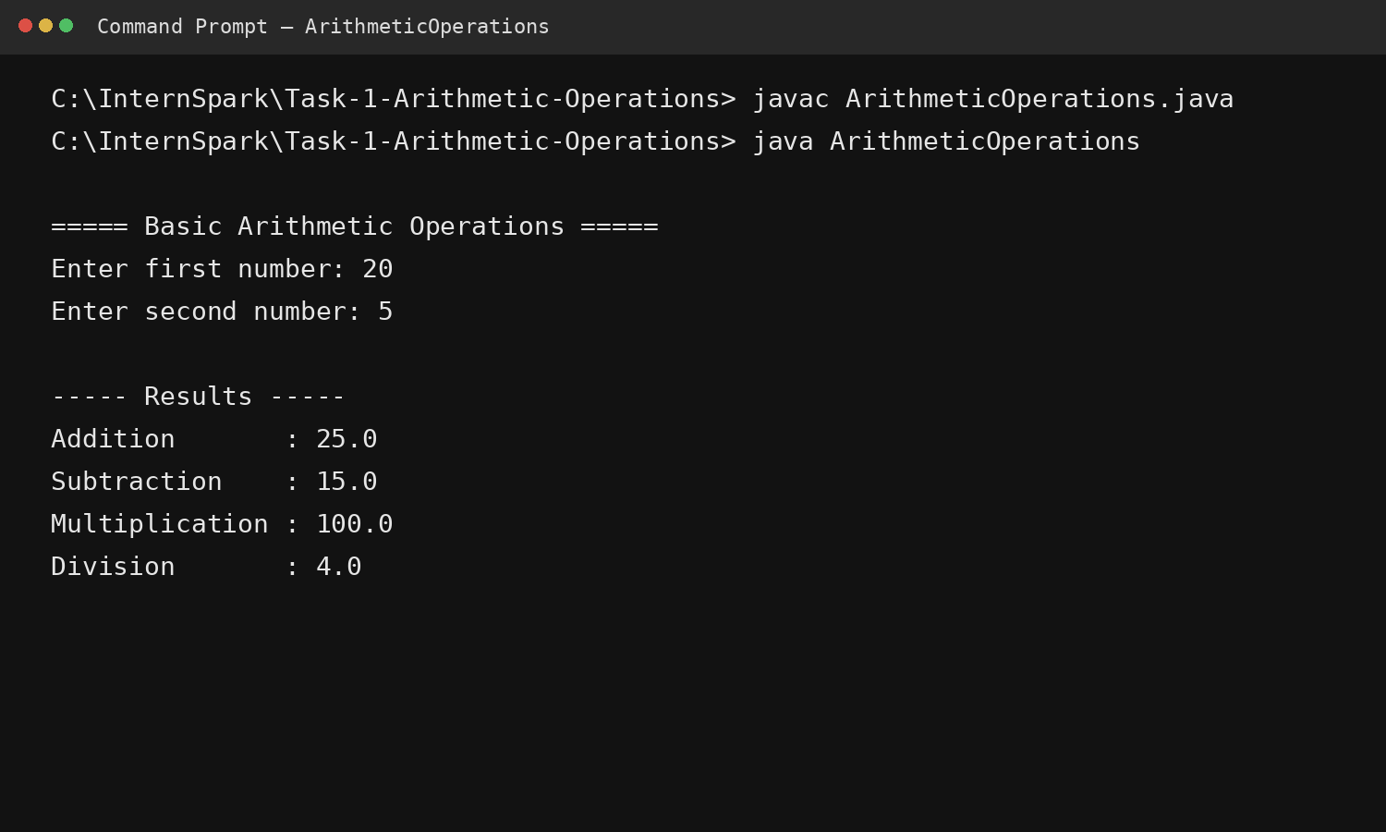
### GitHub Repository

Add your public GitHub repository link here:

`[YOUR GITHUB LINK]`

### Conclusion

This task demonstrates the use of Java variables, arithmetic operators, user input using Scanner, conditional statements, and basic exception-prevention logic.

